**DAILY ONLINE ACTIVITIES SUMMARY**

|  |  |  |  |  |  |  |  |
| --- | --- | --- | --- | --- | --- | --- | --- |
| **Date:** | **25-06-2020** | | | | **Name:** | **Namratha C** | |
| **Sem & Sec** | **8th sem, A sec** | | | | **USN:** | **4AL16CS056** | |
| **Online Test Summary** | | | | | | | |
| **Subject** | | **SMS** | | | | | |
| **Max. Marks** | | **30** | | **Score** | | **No mail received** | |
| **Certification Course Summary** | | | | | | | |
| **Course** | **Introduction to Cyber Security** | | | | | | |
| **Certificate Provider** | | | **Great Learning** | **Duration** | | | **5.5Hr** |
| **Coding Challenges** | | | | | | | |
| **Problem Statement: Program to check whether the given number is Armstrong number** | | | | | | | |
| **Status: Completed** | | | | | | | |
| **Uploaded the report in Github** | | | | **Yes** | | | |
| **If yes Repository name** | | | | **Daily Progress** | | | |
| **Uploaded the report in slack** | | | | **Yes** | | | |

Online Test Details: **No Mail Received**

Certification Course Details:

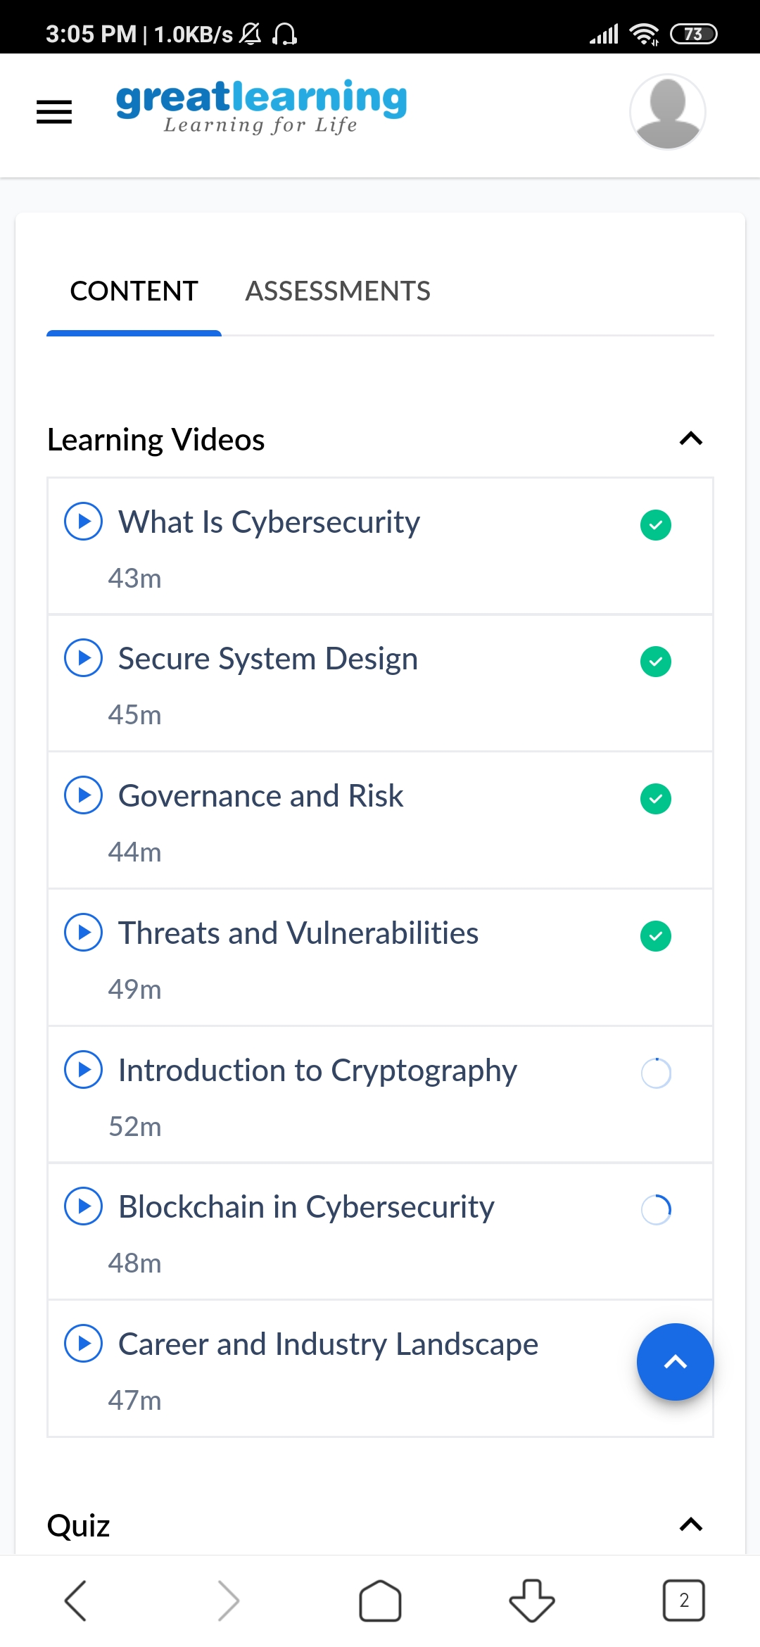

Coding Challenges Details:

public class JavaExample {

public static void main(String[] args) {

int num = 370, number, temp, total = 0;

number = num;

while (number != 0)

{

temp = number % 10;

total = total + temp*temp*temp;

number /= 10;

}

if(total == num)

System.out.println(num + " is an Armstrong number");

else

System.out.println(num + " is not an Armstrong number");

}

}